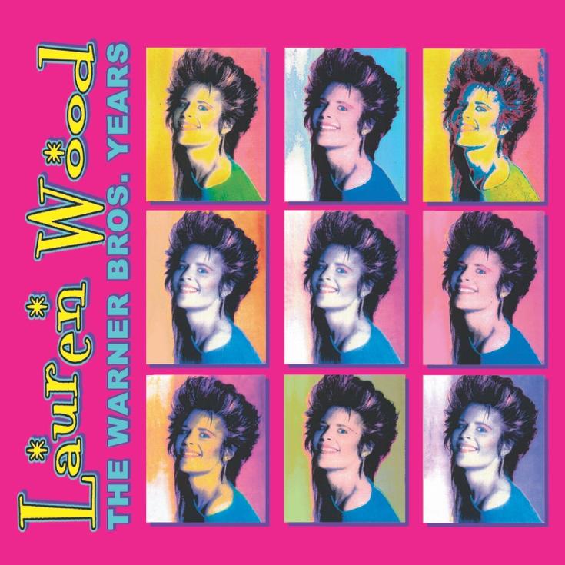
www.blixa.com
LAUREN WOOD'S BEST COMPILED ON NEW SET, THE WARNER BROS. YEARS, DUE FEB. 14 FROM BLIXA SOUNDS
Her hit "Fallen" was featured in the film Pretty Woman.
The 1990 romantic comedy Pretty Woman is notable for its stars, Julia Roberts and Richard Gere, and of course, the theme song that inspired it, Roy Orbison's Number One hit "Oh, Pretty Woman." Yet there's another song closely associated with the film – the adult contemporary smash "Fallen" by Lauren Wood.
That song is the centerpiece of The Warner Bros. Years, a 19-song retrospective that combines Wood's self-titled 1979 album (featuring her soulful hit duet with Michael McDonald of the Doobie Brothers), with Cat Trick, her 1981 follow-up that included "Fallen." The Warner Bros. Years, due Feb. 14 from Blixa Sounds, marks the first time these albums have been released on CD in the U.S. For this release, the recordings have been digitally remastered from the original tapes and packaged with a 16-page booklet, including archival photos as well as lyrics.
Lauren Wood is a Pittsburgh-born singer-songwriter whose career dates back to the mid-'60s when she started the band known as Rebecca & the Sunnybrook Farmers. From there, she went on to sing backing vocals on Frank Zappa's 1973 set The Grand Wazoo and formed the trio Chunky, Novi and Ernie, a family affair with her cousin Novi Novog and bassist Ernie Eremita. The trio went on to record a pair of albums for Warner Bros., the first produced by future Van Halen and Doobie Bros. producer Ted Templeman and former Velvet Underground member John Cale, and the second one by David Campbell, Beck’s father and a well known string arranger.
From there, Wood rightfully took her place in the spotlight, recording her 1979 album under her own name, though Novi and Ernie were still featured. Other musicians on that self-titled debut set included duet partner Michael McDonald and his Doobie Brothers band mate Patrick Simmons; Bill Payne and Fred Tackett of Little Feat; Toto guitarist Steve Lukather, and drummer Jeff Porcaro; hard rocker Ronnie Montrose and ace drummer Jim Keltner.
Cat Trick, which followed in 1981, shared its title with the greeting card company (actually Cat Tricks), featuring photos of her pet cats, Wood had founded earlier. Yet the album is best known for ”Fallen," the song that nine years later enjoyed an unlikely resurgence when it was featured on the Pretty Woman soundtrack, alongside songs by David Bowie, Roy Orbison, the Red Hot Chili Peppers and others. That album went on to sell over 20 million copies, and according to label executives, was the primary force driving sales. The song also earned the ultimate stamp of approval from a diverse set of Wood's peers, including Johnny Mathis, Larry Coyrell and Nicolette Larson, whom all recorded their own versions of the tune. It has even been recorded in Spanish and Chinese!
See what those performers and the producers of Pretty Woman knew -- Lauren Wood is a talent not to be missed. You can catch up with her on The Warner Bros. Years.
EPK video: http://bit.ly/TheWarnerBrosYearsEPK
Amazon buy link: http://bit.ly/TheWarnerBrosYears
For more information or for Lauren Wood interview requests, please contact
Blixa Sounds: Carina Carbetta – carina@manifesto.com

